The Richards Library
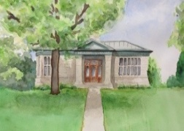
Board of Trustees Meeting Agenda
Thursday, February 12, 2026 @ 11:30 AM
Warrensburg Volunteer Fire Company’s Community Room, 18 Elm Street, Warrensburg, NY 12885

I Call to Order and Roll Call of Members
II Consent Agenda
- Approval of Mtg. Agenda
-
III Period of Public Expression: 15 minutes total for comments

IV Old Business
- Building/Grounds Repairs & Maintenance – will exceed 2026 budgeted line items this month
-

V New Business
- Emergency Closure to the public as of 2/9/2026
-

VI Other Business
-

VII Period of Public Expression: 15 minutes total for comments
VIII Next Committee Workshop: Tuesday, February 17, 2026 @ 10:00 AM – location?
IX Next Board Meeting: Tuesday, March 3, 2026 @ 10:00 AM – location?
X Adjournment

