Winter Break Programming at
The Richards Library
December 17 @ 10:30 AM & December 22 @ 4:00PM – Story Time and Activity
December 17 will be Winter Themed, December 22 will be Holiday Themed! Stories will focus on ages 3-6; other ages are welcome. Parental supervision is required.


December 23 @ 4:30 PM – STEM Project: Origami Paper Circuits
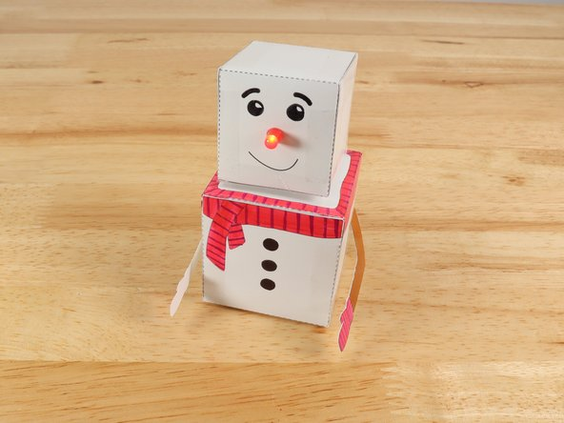
Make some 3D Crafts with light up and moving components using LEDs, Batteries and Maker Tape! Open to all interested youths. Parental supervision is required for children.

December 29 @ 4:00 PM – Teen Craft
Craft for youths ages 13-18. We will be creating custom sand art pictures and drinking hot tea!
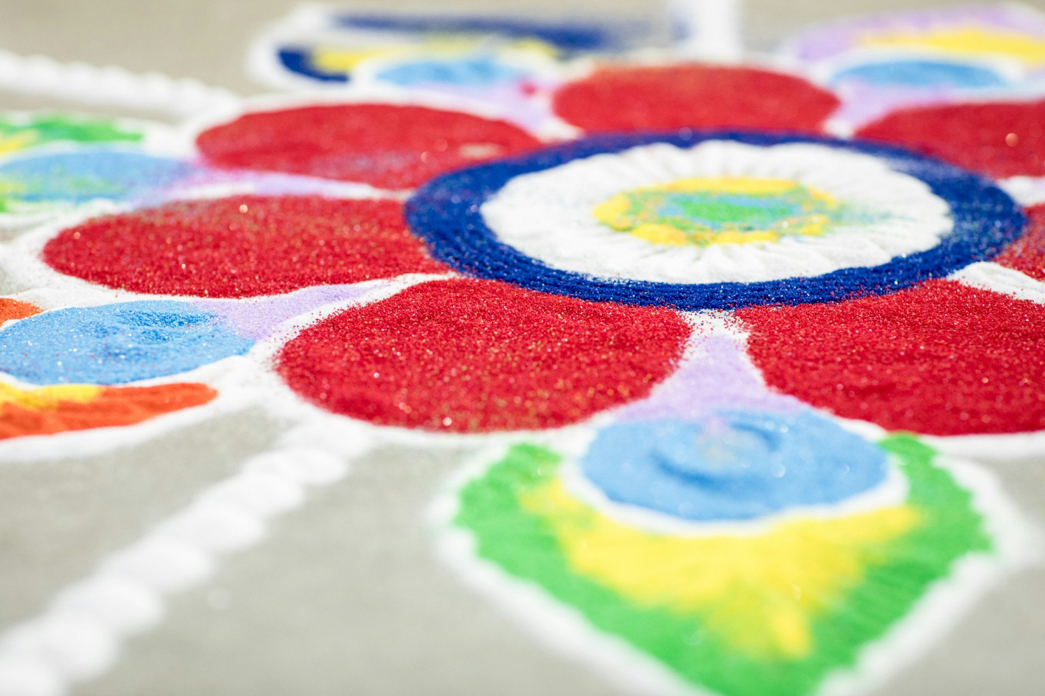

Image credit to Jason Coudriet

December 30 @ 4:30 PM – Games Day
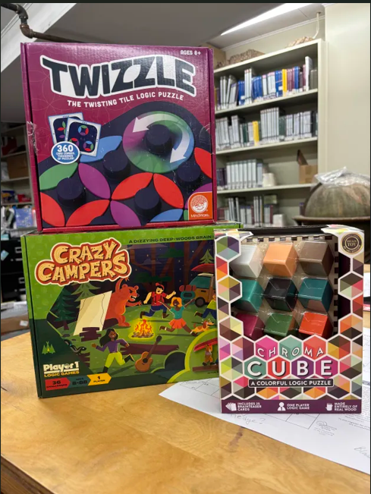
Games Day is open to all youths, drop in to play a variety of Board/Card Games and have some fun! We have so many choices to choose from! Parental supervision is required for children.

January 2 @ 2:30PM – Children’s Film
Stop in for a film on the big screen! We will be showing Moana. Let's get away from the snow/cold and go on an ocean/island adventure! Dressing up encouraged; parental supervision is required for children. Bring comfy blankets for sitting and water to drink; popcorn will be provided. All ages interested may attend!


Image credit to Disney
Winter Break Programming at
The Richards Library
December 17 @ 10:30 AM & December 22 @ 4:00PM – Story Time and Activity
December 17 will be Winter Themed, December 22 will be Holiday Themed! Stories will focus on ages 3-6; other ages are welcome. Parental supervision is required.

December 23 @ 4:30 PM – STEM Project: Origami Paper Circuits
Make some 3D Crafts with light up and moving components using LEDs, Batteries and Maker Tape! Open to all interested youths. Parental supervision is required for children.

December 29 @ 4:00 PM – Teen Craft
Craft for youths ages 13-18. We will be creating custom sand art pictures and drinking hot tea!

Image credit to Jason Coudriet

December 30 @ 4:30 PM – Games Day
Games Day is open to all youths, drop in to play a variety of Board/Card Games and have some fun! We have so many choices to choose from! Parental supervision is required for children.

January 2 @ 2:30PM – Children’s Film
Stop in for a film on the big screen! We will be showing Moana. Let's get away from the snow/cold and go on an ocean/island adventure! Dressing up encouraged; parental supervision is required for children. Bring comfy blankets for sitting and water to drink; popcorn will be provided. All ages interested may attend!

Image credit to Disney

