The Richards Library
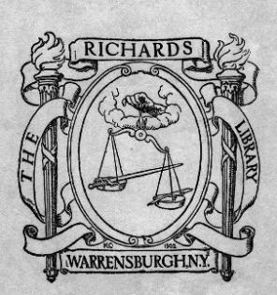
Freedom of Information Law Policy

The following are the rules and regulations of The Richards Library Board of Trustees. They will be reviewed every 5 years or as needed reflect changes in laws, regulations, or Library operations.
Purpose
This policy establishes guidelines for The Richards Library’s compliance with the Freedom of Information Law (FOIL). The Richards Library is an association library, which means it is a nonprofit, privately governed library that serves the public and receives public funds. As such, not all rules governing municipal or public libraries apply. However, The Richards Library voluntarily follows FOIL requirements where applicable in order to maintain transparency with the public.
This policy applies to all physical and electronic records created or received in the course of Library business, including those related to administration, operations, programs, personnel, and finances. The Library strives to follow FOIL by providing access to administrative records, policy documents, meeting minutes, budgets, and other non-confidential information when it is reasonable and does not violate privacy, confidentiality, or contractual obligations.
The Library considers requests for access to records on a case-by-case basis using the following guidelines:
Exemptions and Limitations
The Library reserves the right to deny requests for:
- Records containing personally identifiable patron information (protected under NYS Education Law §4509).
- Personnel or employment records that are confidential.
- Internal working drafts or notes not considered official records.
- Information that would compromise library security or violate legal agreements.
How to Submit a Request
Members of the public may direct information requests in writing to the Library Director, specifying:
- The records or information being requested.
- The purpose or relevance (optional, but helpful).
- Preferred format (viewing in person, digital copy, printed copy, etc.).
Mail a written request to:
The Richards Library
c/o The Library Director
36 Elm Street
Warrensburg, NY 12885
Email a written request to: war-director@sals.edu
Fax a written request to: (518) 623-2426
Submit a written request for records in person:
The Richards Library
36 Elm Street
Warrensburg, NY 12885
This may be done during posted business hours. Advise Staff that you would like to request records and they will contact the Library Director. Please be advised records require review prior to disclosure. As a result, documents and records will not be immediately available.
Response Time and Format
The Library will acknowledge receipt of the request within 2 weeks and provide a written response or status update within 4 weeks, when possible. Requests may be denied if they are unduly burdensome, vague, or requested records are not maintained by the Library. A denial may be appealed in writing to the Board within 1 week of receiving the denial. The Board will respond in writing after the next regularly scheduled meeting and their decision is final. Public is invited to attend regularly scheduled meetings and speak during the two 15-minute public comment periods.
Fees
The Library may charge reasonable fees for physical copies or extensive staff time required to fulfill a request, consistent with Library practices.
Commitment to Transparency
Key governance documents (e.g., board meeting minutes, policies, annual budget, annual reports, and strategic plans) are published on the Library’s website as required by NYS Opening Meeting Law.

Formatted, Reviewed, and Approved by The Richards Library Board of Trustees on November 4, 2025.

