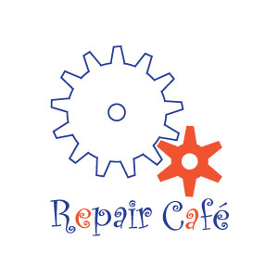Warrensburg

Repair Café

Saturday, June 8, 9:30-11:30 AM

The Richards Library, 36 Elm St, Warrensburg

Bring your Broken but Beloved items

Fix your items for FREE with friendly volunteer Repair Coaches

Bikes, Jewelry, Wooden Items, Clothing,   
Stuffed Toys, Textiles, Computers, Knitting, General Tinkering, Refinishing Furniture

Limit TWO Items Per Person!

Questions? Contact us at warrensburgrepaircafe@gmail.com or 518-744-7554